**Git Repository:** <https://github.com/SorrenJ/IAT339_P03>

**BIO**

**Short Bio (For Animation)**

I am Sorren,

I am specialized with Html and CSS animations.

I have plenty of experience working with CMS.

I am currently learning more about   
javaScript.

In addition to developing websites,

I have a passion for app development.

Like a tree, my goal is to grow and learn new things.

I wish to develop projects that improves accessibility, improves user experience, improves functionality,

or just to simply make people smile.

**Words: 70**

**Long Bio (For About Section)**

Hi there, my name is Sorren, I'm a natural web developer because I enjoy manually coding HTML pages with CSS animations from scratch. I have plenty of experience working with CMS and I always incorporate my naturopathic roots toward developing a professional website.

As a student at School of Interactive Arts & Technology at Simon Fraser University, I study UX design as well as Human Computer Interaction.

With years of experience with front-end web development and user experience, I am driven to develop projects that can contribute to society in a positive way, whether it is by improving accessibility, user experience, functionality, or just to make people smile.

**Words: 108**

**SMART TEST DRIVE**



smartdrivetest.com (SDT) is a learning platform, teaching new and experienced drivers ways to improve driving. It is also an ecommerce website powered by Hikashop that sells online driving courses, podcasts, and books.

Process

Figure 1. Joomla! interface.

Using the CMS Joomla!, I updated the old SDT. As seen in Figure 2. The older site appears rather plain. The website uses very little styling and heavily relies on HTML to decorate content. This makes the older site appear archaic as if it was a site designed from the early 2000s.

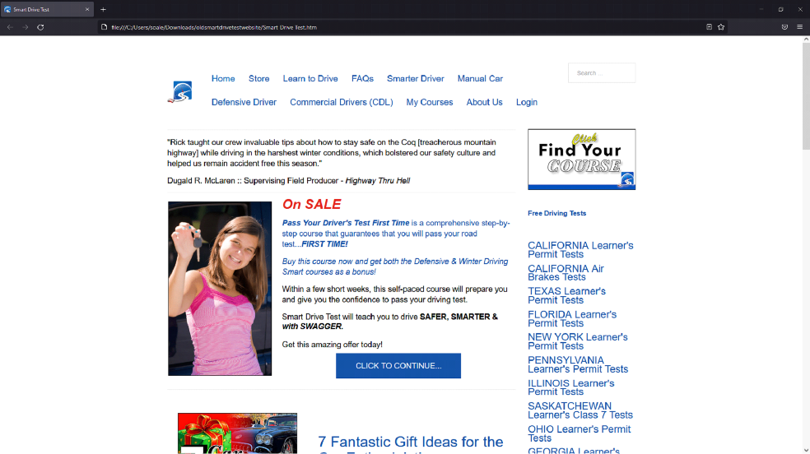

Figure 1. Joomla! interface.

Using the CMS Joomla!, I updated the old SDT. As seen in Figure 2. The older site appears rather plain. The website uses very little styling and heavily relies on HTML to decorate content. This makes the older site appear archaic as if it was a site designed from the early 2000s.



Figure 3. Smart driving school site.

I had several reasons to design the SDT’s landing page and styling differently. The main reason was to set this apart from its competitors like Smart Driving School. Another reason is the structural differences and the hierarchy of content provided by SDT. SDT also had different priorities compared to Smart Driving School. SDT priorities include purchasing audiobooks (driving), listening to the podcasts, booking practice drives, and writing practice tests. Services towards teaching new drivers was a top priority. The formatting of content was also a determining factor towards my design decisions.

I played around with hover functions in conjunction with CSS animations to add a neat effect for the buttons seen in Figure 4.

*Figure 4 code*

Figure 4. Course selection on Landing page.

I also created an animated footer using CSS found on every page as seen in Figure 5. Using the transform rotate selector and preserve-3D property creates a depth of field effect for the moving cars.

*Figure 5 code*

Figure 5. Animated footer using CSS.

Another major design I made towards the landing page was the use of scroll storytelling. As the user scrolls down, the user gathers a summary for what the site is about and what services are offered. When a user opens the page, they would be presented with the major services provided first. As they continue scrolling down they learn a bit about the owner of SDT, and then some featured podcasts. While keeping information concise, users are featured with “read more” links if they choose to see more of a specific content.

The landing page also features the latest SDT youtube video. To always display the latest video I had to embed the SDT's youtube playlist link in the Iframe tag as shown below

<div class="ytp-cued-thumbnail-overlay-image" style="background-image: url(&quot;https://i.ytimg.com/vi_webp/pq270fxNGrM/sddefault.webp&quot;);"></div>

Figure 7. Listing page template.

Reflection

After leaving Cybersalt Consulting, SDT has been fully functional since. A large number of customers use this site today whether for purchasing services, taking courses, or listening to podcasts. Rick August, the owner of Smart Drive Test, very much appreciates what I've done with the landing page, especially my CSS Animations and considers this a nice touch towards the branding.

<iframe width="100%" height="315" src="https://www.youtube.com/embed/wBIIMhGBrmg" title="YouTube video player" frameborder="0" allow="accelerometer; autoplay; clipboard-write; encrypted-media; gyroscope; picture-in-picture" allowfullscreen></iframe>

**PROFILE HELPER**

Profile helper is a content generator tool to help with creating graduate student profile pages. It was developed with JavaScript jQuery. It contains save and download functions, and a text editor to test out the webpage content. As a result it boosted work productivity with graduate student profiles.

 <iframe width="100%" height="315" src="https://www.youtube.com/embed/tY4R7WL1pVg" title="YouTube video player" frameborder="0" allow="accelerometer; autoplay; clipboard-write; encrypted-media; gyroscope; picture-in-picture" allowfullscreen></iframe>

Profile helper is a content generator tool to help with creating graduate student profile pages. It was developed with JavaScript jQuery. It contains save and download functions, and a text editor to test out the webpage content. As a result it boosted work productivity with graduate student profiles.

<a href="https://sorrenj.github.io/Profile_Helper.html" target="_blank">

<button class="button"> Visit Website → </button></a>

As a Design and Marketing Associate for Simon Fraser University Graduate and Postdoctoral Studies one of my responsibilities was to design profile pages using Adobe Experience Manager (AEM). I was also responsible for updating the various web pages found in the GPS site such as the job page, event page, awards page, and had coded the template for the GPS news bulletin. Last minute profile submissions have piled up since winter break of 2020. Perhaps Graduate students had more time to submit it over the break. With over 60 profiles to be completed within a short time frame, the volume is overwhelming. My solution for this problem was to create a program to aid with the formatting. This generates a premade template for the profile pages. As a result of my innovation I was able to complete the profile pages at a faster rate with more consistency.

Process

My supervisor was proud of my innovations in accomplishing this task and required the Profile Helper to continue with operations within the department especially when there were large volumes of profiles requested. Unfortunately, there was a problem with my prototype Profile Helper. This version was built with the scripting programming language: Hypertext Preprocessor, which deals with web server functionalities and was not accessible to the department. I finally decided to use jQuery as an alternative programming language to build the Profile Helper. jQuery is a JavaScript library that can be used to create dynamic webpages. While using jQuery, I could generate profile templates just like before and accessible for my supervisor. This function was perfect for my Profile Helper as it allowed me to change string values by user input without the need of a server environment. $(selector).val() allowed me to return what the user had inputted.

$(selector).val(value) Placing (value) allows the user to to set the value and can be set through the html tag <input>

<input type="text" onclick="this.select()" id="LinkedIn">

This snippet of html code above results with an input form. When I make id=”LinkedIn", whatever the user inputs in the field, the string will be stored in the “LinkedIn” id. After setting the value I can return the value by: $(‘#LinkedIn’).val(), <input> with $(selector).val(). I can form a concatenation of string values to form a sentence or a body of text.

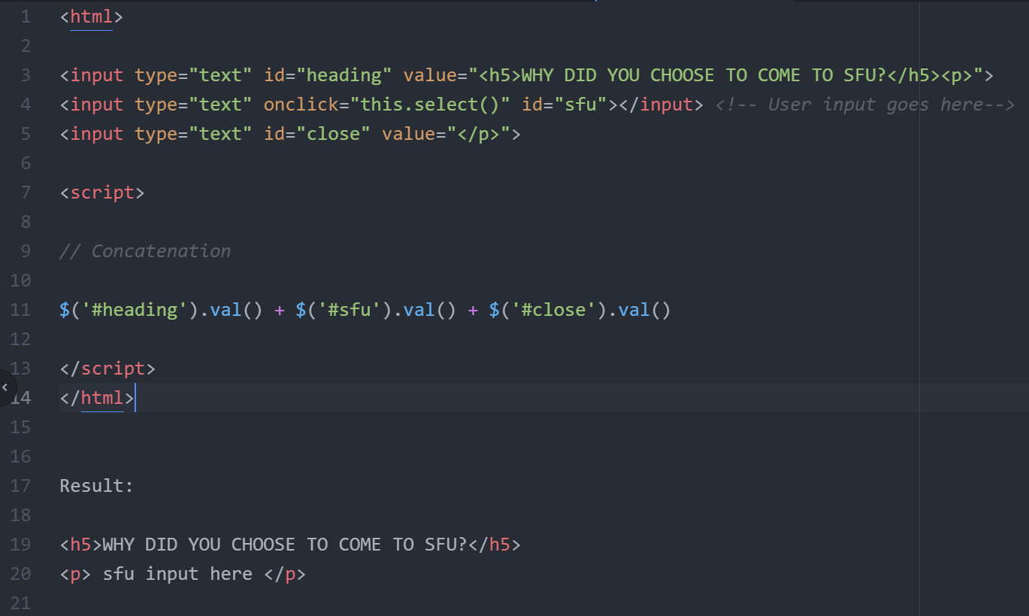

Figure 1: Snippet of jQuery concatenation of string values along with the HTML input code. This outputs a heading and a user-created paragraph.

The possibilities are great with input concatenation as it also allows the user to input url links, email addresses and hyperlink them into text.

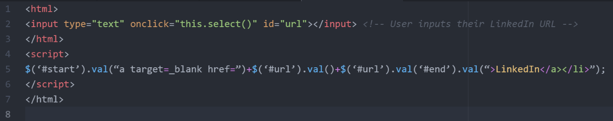

Figure 2: Snippet of jQuery concatenation allowing users to insert their LinkedIn link in a body of text. This outputs a clickable link to their LinkedIn page.

I had also improved the user experience within the Profile Helper. This user-friendly version contains color-coded buttons, tabs to separate content, save and download functions, and a text editor to test out the generated html.

Figure 3: A screenshot of my Profile Helper. Users can input their details here.

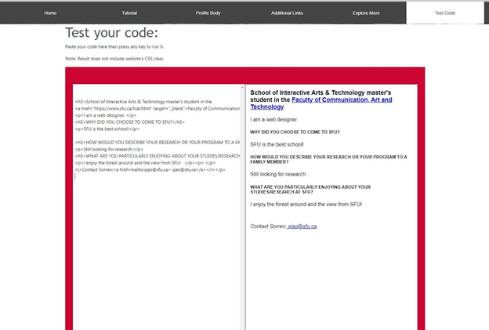

Figure 4: A screenshot of my Profile Helper. Users can test their HTML code in this page and view how it would look on the profile page.

Reflection

As a result of my innovation - a tool to aid with profile creations, my supervisor shared my work with the GPS staff and all was grateful for my innovation. Minor tweaks were made based on her feedback.

Looking back, I realized that if it weren’t for the numerous profile requests, this project would not have existed. The deadlines and the profile requests unexpectedly taught me the fundamentals of Hypertext Preprocessor and jQuery.

I compared my project to the assembly system of McDonald's from the way it seamlessly automates and generates burgers. One might say that this method of automation diminishes the quality of McDonald's food (No offense to McDonalds). However, this method does not diminish the quality of a profile as one may believe, rather it assists users with the process of creating quality content by allowing them to begin with a template.